**MACHINE LEARNNG**

Machine Learning is the field of study that gives computers the capability to learn without being explicitly programmed. ML is one of the most exciting technologies that one would have ever come across. As it is evident from the name, it gives the computer that makes it more similar to humans: The ability to learn. Machine learning is actively being used today, perhaps in many more places than one would expect. Machine Learning is said as a subset of **artificial intelligence** that is mainly concerned with the development of algorithms which allow a computer to learn from the data and past experiences on their own. The term machine learning was first introduced by **Arthur Samuel** in**1959.**

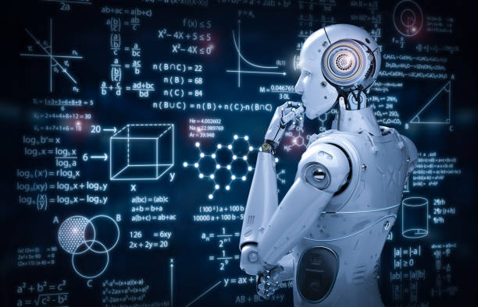

How does Machine Learning work?

A Machine Learning system **learns from historical data, builds the prediction models, and whenever it receives new data, predicts the output for it.** The accuracy of predicted output depends upon the amount of data, as the huge amount of data helps to build a better model which predicts the output more accurately.

Suppose we have a complex problem, where we need to perform some predictions, so instead of writing a code for it, we just need to feed the data to generic algorithms, and with the help of these algorithms, machine builds the logic as per the data and predict the output. Machine learning has changed our way of thinking about the problem. The below block diagram explains the working of Machine Learning algorithm:

## 

## Classification of Machine Learning:

## There are three types of machine learning-

1. Supervised learning
2. Unsupervised learning
3. Reinforcement learning

**Supervised Learning:**

Supervised learning is a type of machine learning method in which we provide sample labeled data to the machine learning system in order to train it, and on that basis, it predicts the output.

The system creates a model using labeled data to understand the datasets and learn about each data, once the training and processing are done then we test the model by providing a sample data to check whether it is predicting the exact output or not.

The goal of supervised learning is to map input data with the output data. The supervised learning is based on supervision, and it is the same as when a student learns things in the supervision of the teacher. The example of supervised learning is **spam filtering.**

Supervised learning can be grouped further in two categories of algorithms:

* **Classification**
* **Regression**

**What is Classification:**

The Classification algorithm is a Supervised Learning technique that is used to identify the category of new observations on the basis of training data. In Classification, a program learns from the given dataset or observations and then classifies new observation into a number of classes or groups. Such as, **Yes or No, 0 or 1, Spam or Not Spam, cat or dog,** etc. Classes can be called as targets/labels or categories.

The best example of an ML classification algorithm is **Email Spam Detector.**

**What is regression?**

Regression analysis is a statistical method to model the relationship between a dependent (target) and independent (predictor) variables with one or more independent variables. More specifically, Regression analysis helps us to understand how the value of the dependent variable is changing corresponding to an independent variable when other independent variables are held fixed. It predicts continuous/real values such as **temperature, age, salary, price,** etc.

### **Unsupervised Learning:**

Unsupervised learning is a learning method in which a machine learns without any supervision.

The training is provided to the machine with the set of data that has not been labeled, classified, or categorized, and the algorithm needs to act on that data without any supervision. The goal of unsupervised learning is to restructure the input data into new features or a group of objects with similar patterns.

In unsupervised learning, we don't have a predetermined result. The machine tries to find useful insights from the huge amount of data. It can be further classifieds into two categories of algorithms:

* **Clustering**
* **Association**

**What Is Clustering?**

Clustering is the task of dividing the population or data points into a number of groups such that data points in the same groups are more similar to other data points in the same group than those in other groups. In simple words, the aim is to segregate groups with similar traits and assign them into clusters.

**What is Association?**

Association rule learning is a type of unsupervised learning technique that checks for the dependency of one data item on another data item and maps accordingly so that it can be more profitable. It tries to find some interesting relations or associations among the variables of dataset. It is based on different rules to discover the interesting relations between variables in the database.

**Reinforcement Learning**

Reinforcement learning is a feedback-based learning method, in which a learning agent gets a reward for each right action and gets a penalty for each wrong action. The agent learns automatically with these feedbacks and improves its performance. In reinforcement learning, the agent interacts with the environment and explores it. The goal of an agent is to get the most reward points, and hence, it improves its performance.

The robotic dog, which automatically learns the movement of his arms, is an example of Reinforcement learning.